**Build Infrastructure**

%TOC%

**Overview**

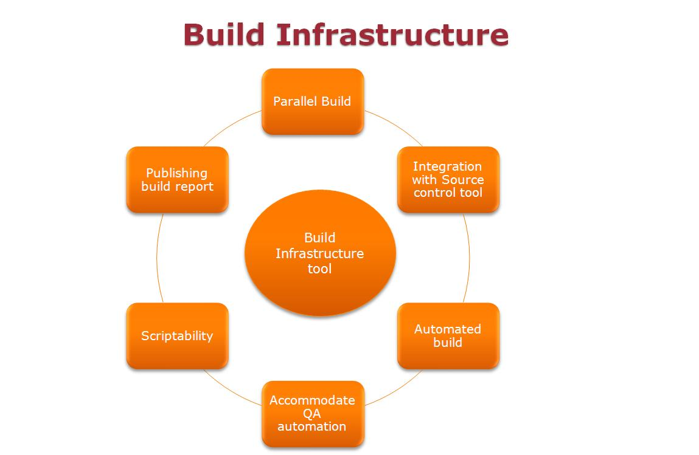

**Choices**

1. Jenkins (Hudson)
2. Cruise Control
3. AntHill
4. Luntbuild
5. Continuum

**InMobi Use Cases**

1. Core Features
   1. Parallel builds
   2. Ability to fire build automatically and manually.
   3. Notification on fail builds.
2. Easy onboarding
   1. Service as Self service
      1. Engineers will have access to the system to configure their project
      2. No project level support from SCM, Only application support to run the tool.
   2. Service as SCM manage service
      1. Engineers have to follow the SCM process and guidline. http://twiki.corp.inmobi.com/SCM/ScmWorkFlow
3. Web Interface/Dashboards
   1. User dashboard
   2. Admin Dashboard
4. Integration with testing framework
   1. Ability to run QA automation
5. Scritability or flexibility to use external commands
   1. Feature to run shell script, perl script etc as part of build or post build activity.
6. Publish reports
   1. Build success rate.
   2. Changes in the build.
   3. Test reports
7. SCM integration
   1. integration to source control tool uses in InMobi.
8. Integration with build systems
   1. Able to build with Maven.
9. Audit
   1. Keep history of the builds and able to reproduce.
   2. Files changed/used for the build.
10. Authentication
    1. No need to separate authentication for user to view the user dashboard
11. Authorization
    1. Restricted operation- Add, delete, Modify jobs control by admin.
12. Availability
    1. High availability
    2. Easy and quick to recover from backup and configurable.
13. Administration
    1. Separate administration privilege and dashboard.
    2. Low entry barrier
    3. Easy to manage users and their roles.
    4. Automated backup.
14. Service Monitoring
    1. Uptime
    2. Availability

**Comparison**

%EDITTABLE{}%

|  |  |  |  |  |  |  |
| --- | --- | --- | --- | --- | --- | --- |
| **Tools Vs Features** | **Easy Onboarding** | **Core Feature** | **SCM Integration** | **Test Tool Integration** | **Scriptability/Flexibility** | **Access Control** |
| **Jenkins** | Yes | Yes | Yes | Yes | Yes | Yes |
| **Crise Control** | No | Yes | Yes | Few | Yes | Partial |
| **Luntbuild** | No | Yes | Yes | Unknown (Most cases) | Yes | Yes |
| **AntHill** | No | patial | Yes | Unknown (Most cases) | No | No |
| **Continuum** | No | Yes | Yes | Unknown (Most cases) | Yes | Yes |

Looking at above table and use cases Jenkins is our best choice.

-- Main.VishalSahasrabuddhe - 2012-03-09